Code Question
Screen 1
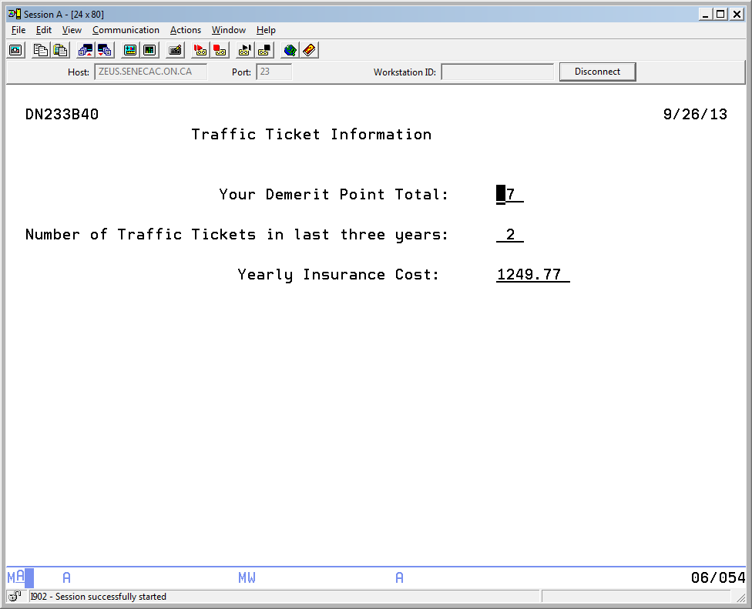
Screen 1 and and overlay of screen 2 (input not allowed on first screen)
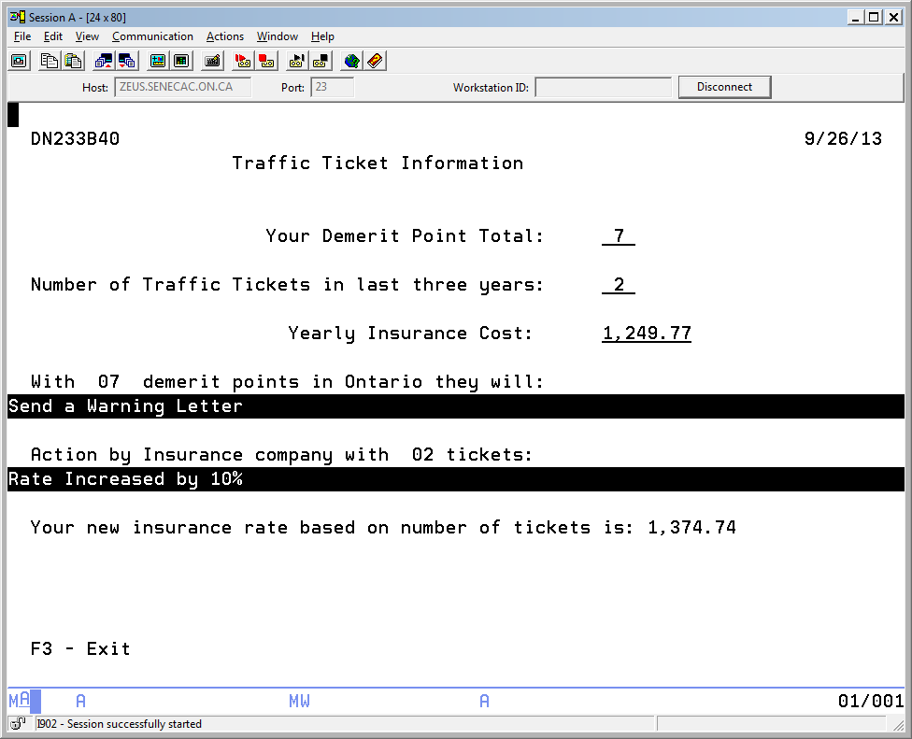
Fields reset after enter is pressed and input allowed on first screen
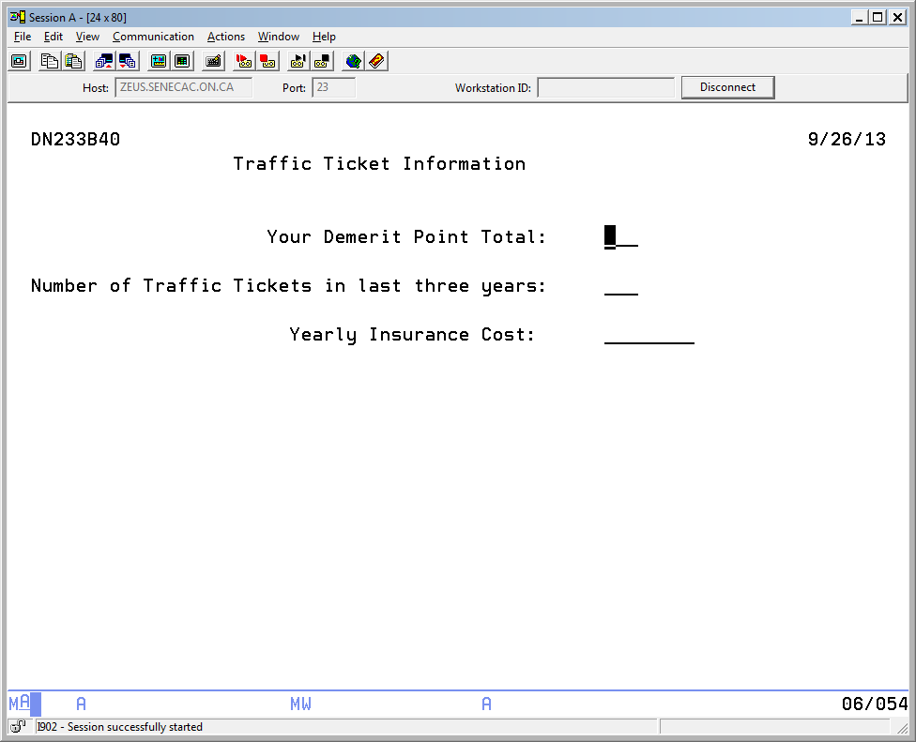
Values entered and enter is pressed
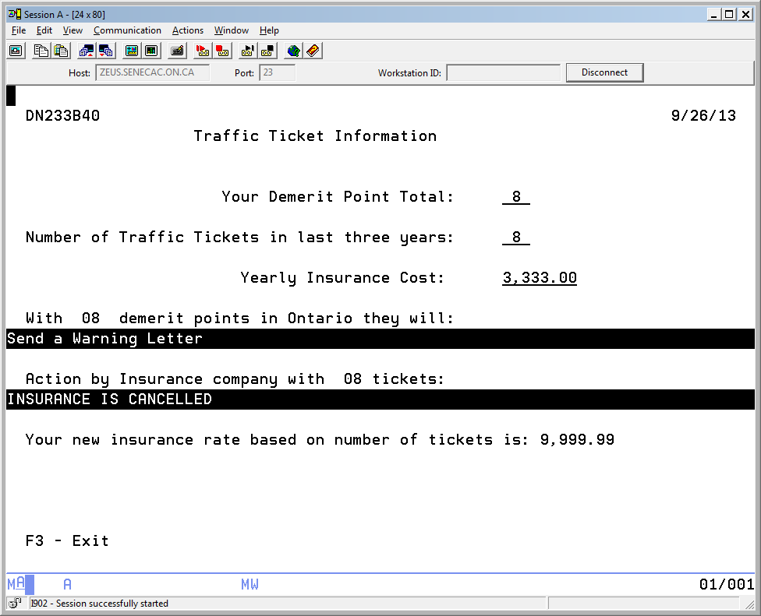

Display File Code (TICKETDSP)

A R GETINFO
A 3 21'Traffic Ticket Information'
A 2 71DATE
A EDTCDE(Y)
A 2 3USER
A 6 24'Your Demerit Point Total:'
A 8 3'Number of Traffic Tickets in last -
A three years:'
A DEMERITS 2 0B 6 54
A 99 DSPATR(PR)
A NMTICKET 2 0B 8 54
A 99 DSPATR(PR)
A 10 26'Yearly Insurance Cost:'
A INSURANCE 6 2B 10 54EDTCDE(2)
A 99 DSPATR(PR)
A R SHOWINFO CF03(03) OVERLAY
A 12 13'demerit points in Ontario they wil-
A l:'
A 15 3'Action by Insurance company with '
A NMTICKET 2 0O 15 37
A 12 3'With '
A DEMERITS 2 0O 12 9
A RESULT1 80 O 13 1DSPATR(RI)
A RESULT2 80 O 16 1DSPATR(RI)
A 18 3'Your new insurance rate based on n-
A umber of tickets is:'
A NEWRATE 6 2O 18 58EDTCDE(1)
A 23 3'F3 - Exit'
A 15 40'tickets: '

Processing.

First screen allows demerit points, number of tickets and current insurance cost to be entered. First and overlayed second screen shows the results of those entries in three fields. Values can be entered when both screens show. When the second screen is showing, The user can press enter to try out different scenarios or press F3 to exit the program. The user can only press F3 when the second screen is showing. If the user presses F3, you do not want to show the first screen before exiting.

The fields on the first screen are protected from user input whenever both screens show. They are not protected when the just the inquiry screen shows.

Use a subroutine called GetReuslts for all your results and calculations
Demerit Points | Message
0 to 2 points | No action taken
3 to 8 points | Send a Warning Letter
9 to 14 points | Review Licence for possible suspension and possible interview request
Anything larger | Suspended license for thirty days

Ignoring the demerit points, if the person has had 0 or 1 tickets in the last three years the second message should indicate ‘no adjustment done’. A person with 2 tickets should be told: ‘Rate Increased by 10%’ and be shown what the adjusted rate is. The person with 3 tickets would have a 20% upward adjustment. Anyone with 4 or more tickets would be told ‘INSURANCE IS CANCELLED', with an adjusted rate of 9999.99.
Make sure you use the appropriate names based on the supplied DDS display file code in the file called TICKETDSP.

